

**UNIVERSITY OF ASIA PACIFIC**

**Department of Computer Science & Engineering**

|  |
| --- |
| VLSM with RIP |

**Course Code :** CSE 320

**Course Title :** Computer Networks Lab

**Submitted by: Submitted To: Name :** Sheikh Nafez Sadnan Md. Akhtaruzzamman Adnan **Reg. No. :** 20101106 Assistant Professor

**Roll No. :** 106 Department of CSE

**Section :** B (2) University of Asia Pacific

**Definition of RIP**

Routing Information Protocol (RIP) is a **dynamic distance-vector routing protocol**. Routers running the distance-vector protocol send all or a portion of their routing tables in routing-update messages to their neighbors. We can use RIP to configure the hosts as part of a RIP network. It uses hop count as a routing metric to find the best path between the source and the destination network. It is a distance-vector routing protocol that has an AD value of 120 and works on the Network layer of the OSI model. RIP uses port number 520.

**Features of RIP**

-Updates of the network are exchanged periodically.   
 -Updates (routing information) are always broadcast.   
 - Full routing tables are sent in updates.   
 - Routers always trust routing information received from neighbor routers. This is also known as *Routing on rumors*.

**RIP Versions**

There are three versions of routing information protocol – **RIP Version1**, **RIP Version2**, and **RIPng**.

**RIP Version-1:**

It is an open standard protocol means it works on the various vendor’s routers. It works on most of the routers, it is classful routing protocol. Updates are broadcasted. Its administrative distance value is 120, it means it is not reliable, The lesser the administrative distance value the reliability is much more. Its metric is hop count and max hop count is 15. There will be a total of 16 routers in the network. When there will be the same number of hop to reach the destination, Rip starts to perform load balancing. Load balancing means if there are three ways to reach the destination and each way has same number of routers then packets will be sent to each path to reach the destination. This reduces traffic and also the load is balanced. It is used in small companies, in this protocol routing tables are updated in each 30 sec. Whenever link breaks rip trace out another path to reach the destination. It is one of the slowest protocol.

**RIP Version-2:**

The **Routing Information Protocol, version 2 (RIPv2)** is an enhanced version of RIP that includes support for important routing features such as class-less addressing and variable-length subnet masks. RIPv2 is a distance-vector protocol that has been in use for many years.

**RIPng:**

The RIPng IGP uses the Bellman-Ford distance-vector algorithm to determine the best route to a destination, using hop count as the metric. RIPng allows hosts and routers to exchange information for computing routes through an IP-based network. RIPng is intended to act as an IGP for moderately-sized autonomous systems.

RIPng is a distinct routing protocol from RIPv2. The Junos OS implementation of RIPng is similar to RIPv2.

**VLSM**

We have a limited number of private IPv4 addresses that can be used in every organization. As the Internet and most organizations are aggressively growing, we need a way to eliminate wasting IPv4 addresses. One of the ways that we can maximize the use of private IPv4 addresses in the organization is through subnetting.

The reason why we need subnetting is to efficiently distribute an IPv4 address with the least wastage and to create more networks with the smaller broadcast domains. To efficiently use subnetting, we can use Variable-Length Subnet Mask (VLSM).

It is a concept that is used to divide a network into multiple subnetworks of different lengths and sizes. VLSM is very commonly used in various fields. For example, a college has a huge network that is divided into multiple sub-networks (one sub-network for the administration department, another for the academics department, etc.).

With Variable-Length Subnet Mask (VLSM), we can allot the closest required number of IP addresses into a subnetwork in our LAN. We don’t need to use a /23 subnet mask in all of our subnets.

**Advantages of VLSM over FLSM –**

1. In Fixed length subnet mask subnetting (FLSM), all subnets are of equal size and have equal number of hosts but in VLSM the size is variable and it can have variable number of hosts thus making the IP addressing more efficient by allowing a routed system of different mask length to suit requirements.
2. In FLSM there is a wastage of IP addresses but in VLSM there is a minimum wastage of IP addresses, it leads to lesser wastage of IP addresses since variable-sized sub-networks are allowed in VLSM.
3. FLSM is preferred for private IP addresses while for public IP addresses VLSM is the best option.
4. VLSM gives us more flexibility in creating a sub-network because of its variable size sub-network nature.
5. VLSM is suitable for public network IP addressing since, in the public domain, the size of a network can vary. In contrast, FLSM is used for private network IP addresses.

How to implement **VLSM with RIP**

**Step-1:** Open a project in Cisco Packet Tracer.Take router, switch, PC & laptop’s from the drop down menu. The amount of these equipment’s depends on the architecture of the project.

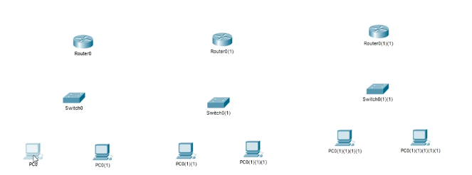

**Step-2:** Rename the equipment’s to avoid confusion.

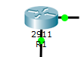

**Step-3:** Connect the individual routers.

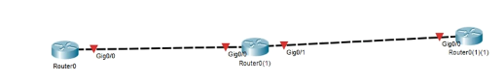

**Step-4:** Connect router with switch.

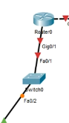

**Step-5:** Connect switches with PC’s and laptops.

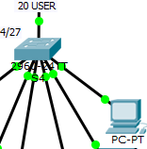

**Step-6:** Note down the IP addresses.



**Step-7:** Define user limits.

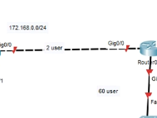

**Step-8:** Open a web browser, go to http://www.vlsmcalc.com/

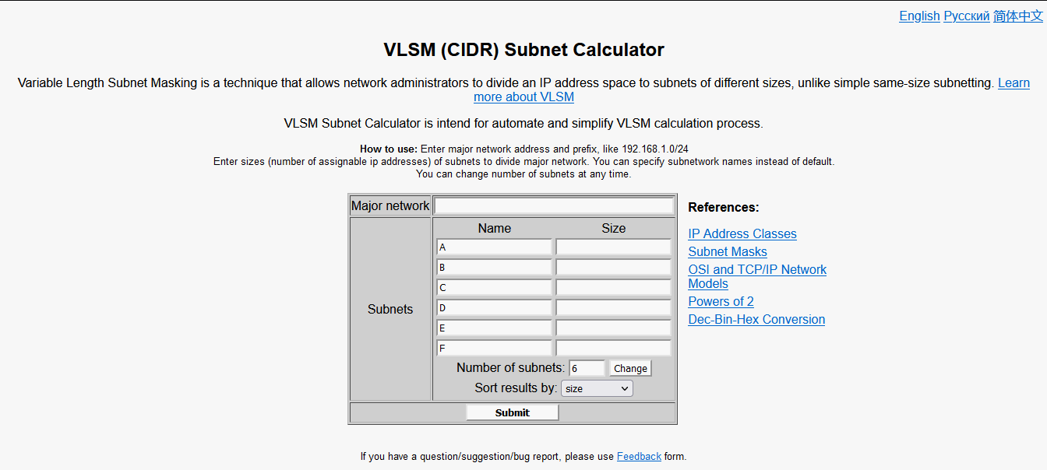

**Step-9:** Input major network, number of subnets and size.

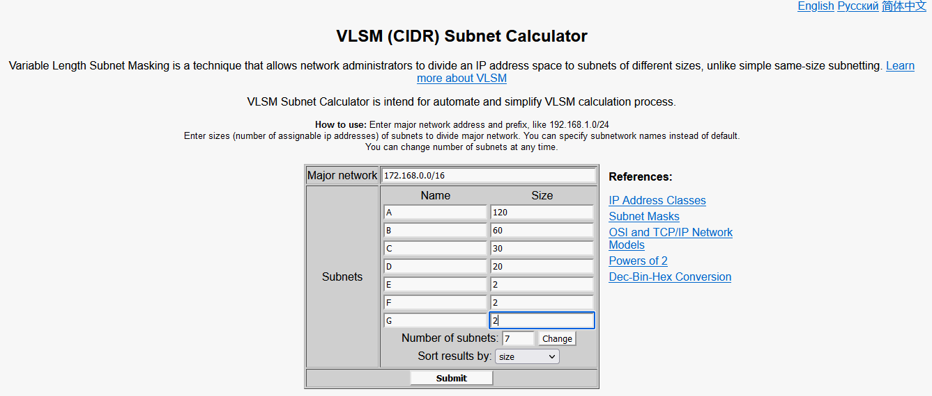

**Step-10:** Click submit, subnetting is successful.

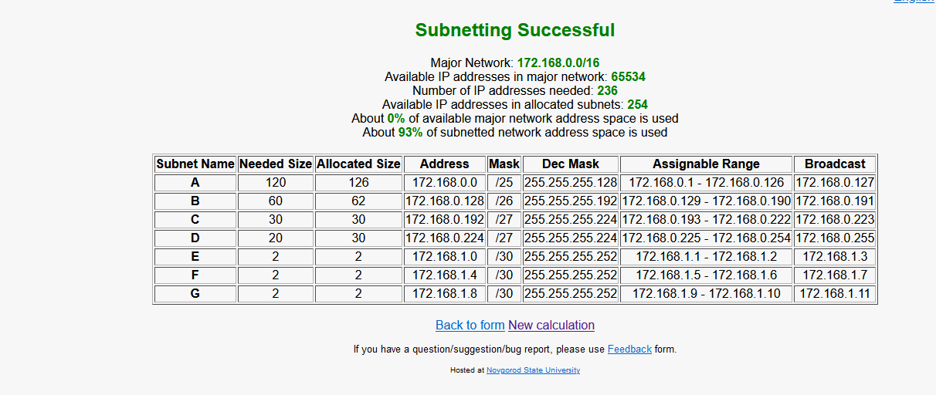

**Step-11:** Note down the addresses. The addresses are-

For 120, 60 and 30 user-

*172.168.0.0/25*

172.168.0.128/26

172.168.0.192/27

172.168.0.224/27

For 3 users, the IP addresses are-

172.168.1.0/30

172.168.1.4/30

172.168.1.8/30

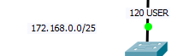

**Step-12**: Configure each routers. For router 1,2,3 and 4 the codes are-

*enable*

*configure terminal*

*int g0/0*

*ip address 172.168.1.1 255.255.255.252*

*no shutdown*

*exit*

*int g0/1*

*ip address 172.168.0.1 255.255.255.128*

*no shutdown*

*enable*

*configure terminal*

*int g0/0*

*ip address 172.168.1.2 255.255.255.252*

*no shutdown*

*exit*

*int g0/2*

*ip address 172.168.0.129 255.255.255.192*

*no shutdown*

*exit*

*int g0/1*

*ip address 172.168.1.5 255.255.255.252*

*no shutdown*

*enable*

*configure terminal*

*int g0/0*

*ip address 172.168.1.6 255.255.255.252*

*no shutdown*

*exit*

*int g0/2*

*ip address 172.168.0.193 255.255.255.224*

*no shutdown*

*exit*

*int g0/1*

*ip address 172.168.1.9 255.255.255.252*

*no shutdown*

*enable*

*configure terminal*

*int g0/0*

*ip address 172.168.1.10 255.255.255.252*

*no shutdown*

*exit*

*int g0/1*

*ip address 172.168.0.225 255.255.255.224*

*no shutdown*

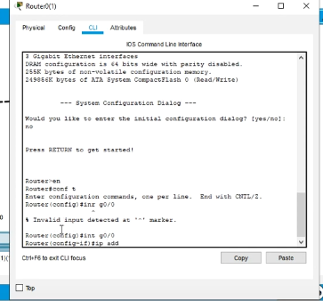

**Step-13:** Go to CLI of each routers and command-

*show ip route*

to see directly connected ip addresses-

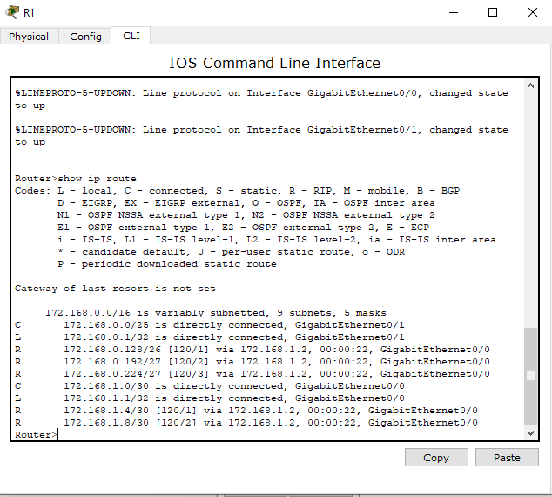

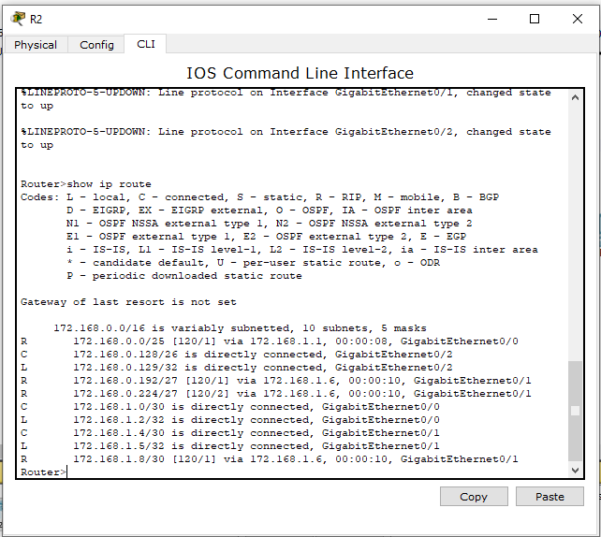

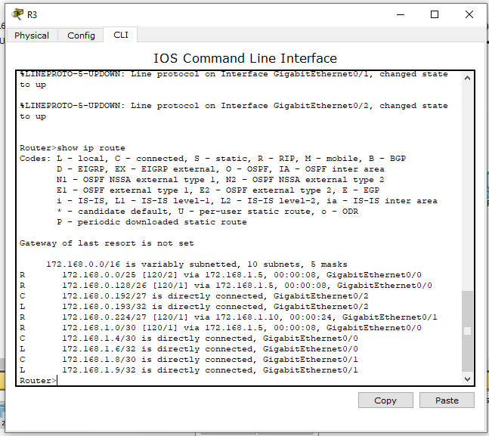

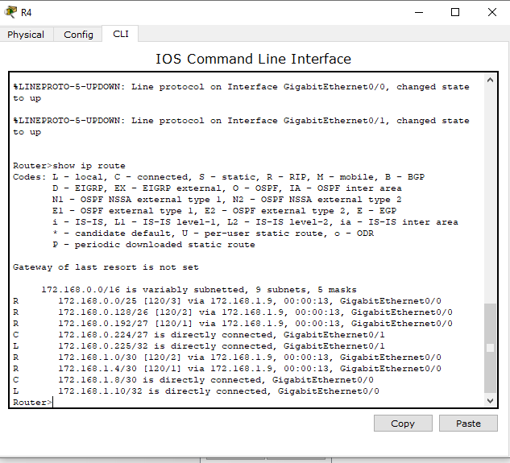

**Step-14:** Go to router 1 and write down the above code in CLI-

*configure terminal*

*router rip*

*network 172.168.0.0*

*network 172.168.1.0*

*no auto-summary*

*version 2*

Similarly, go to router 2 and write down the above code in CLI-

*configure terminal*

*router rip*

*network 172.168.0.128*

*network 172.168.1.0*

*network 172.168.1.4*

*no auto- summary*

*version 2*

Similarly, go to router 3 and write down the above code in CLI-

*configure terminal*

*router rip*

*network 172.168.0.192*

*network 172.168.1.4*

*network 172.168.1.8*

*no auto-summary*

*version 2*

Similarly, go to router 4 and write down the above code in CLI-

*configure terminal*

*router rip*

*network 172.168.0.224*

*network 172.168.1.8*

*no auto-summary*

*version 2*

**Step-15:** Go to pc/laptop, then click on desktop and then ip configuration. Set ip address, subnet mask and default gateway. I’m using (for router 1)-

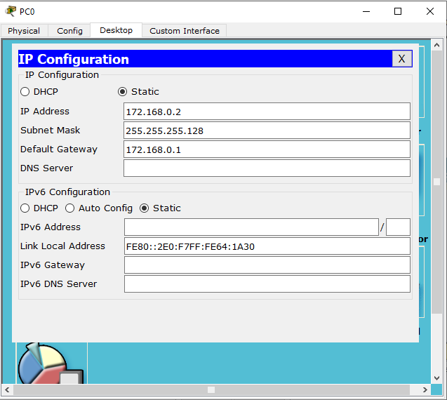

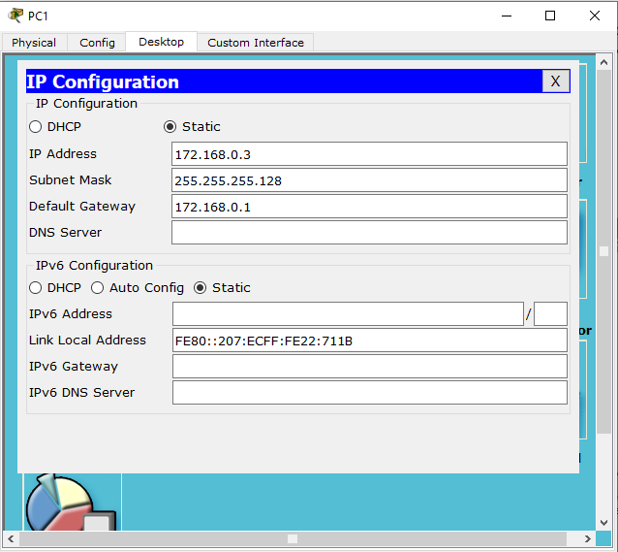

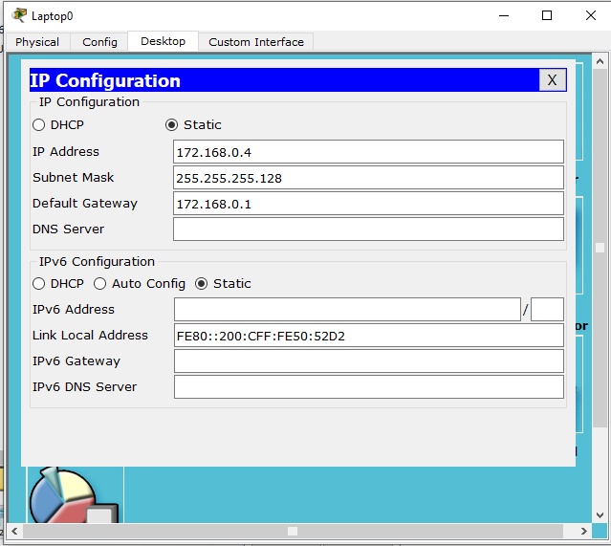

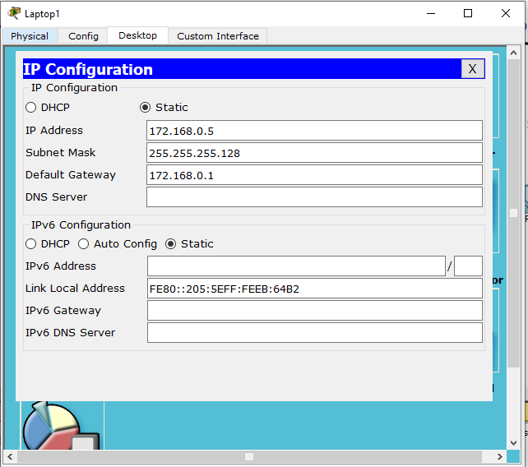

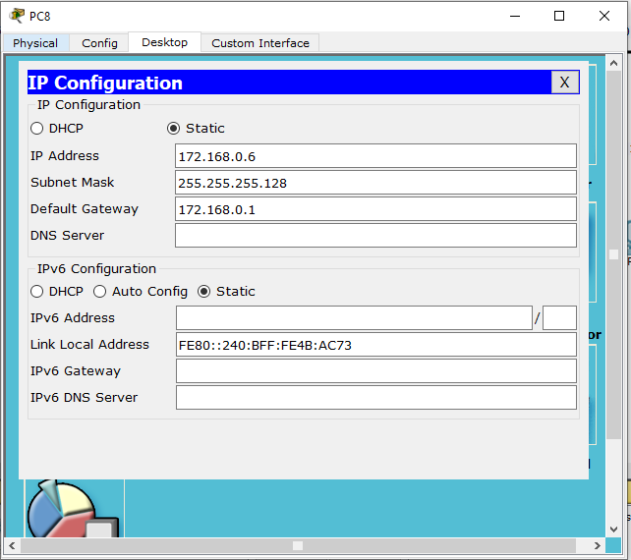

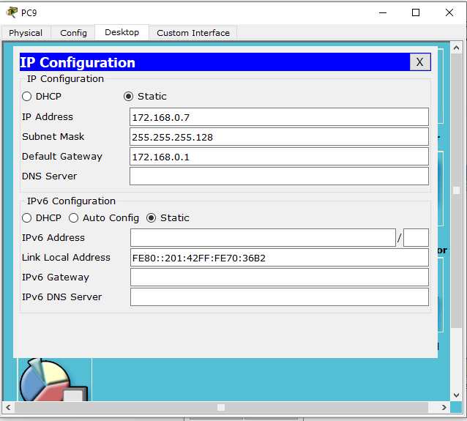

For router-2

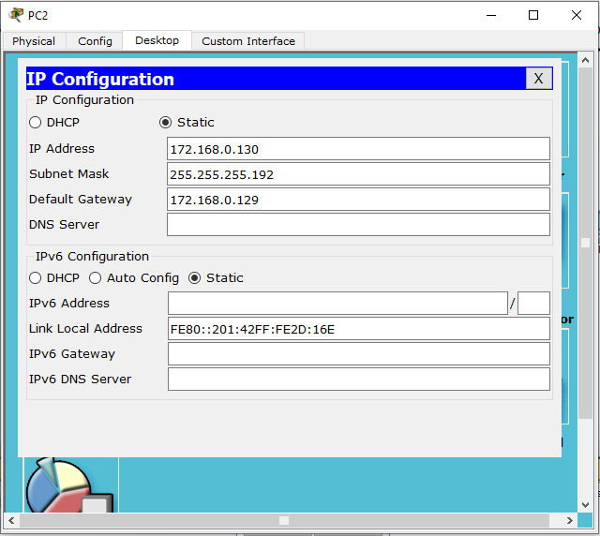

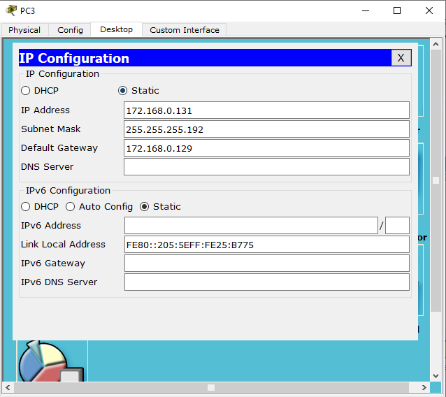

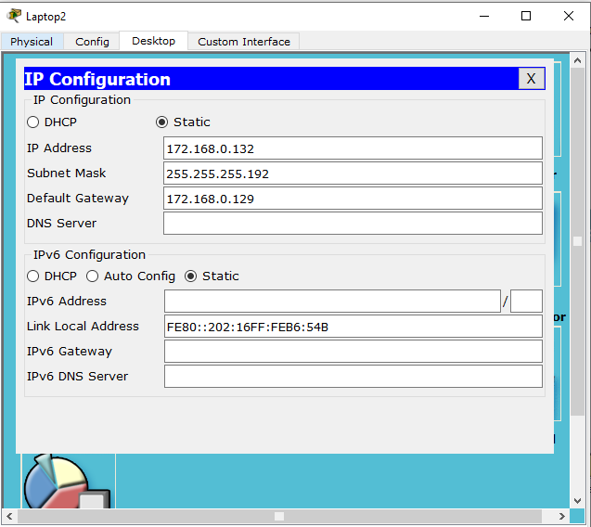

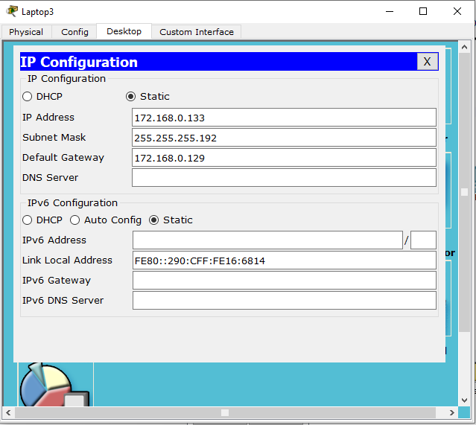

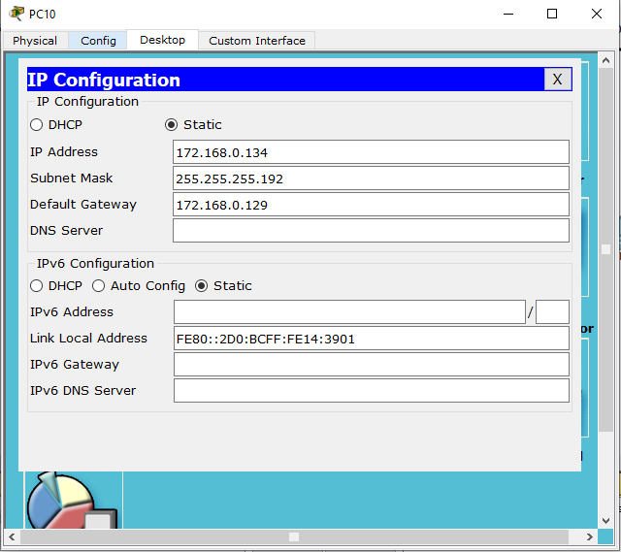

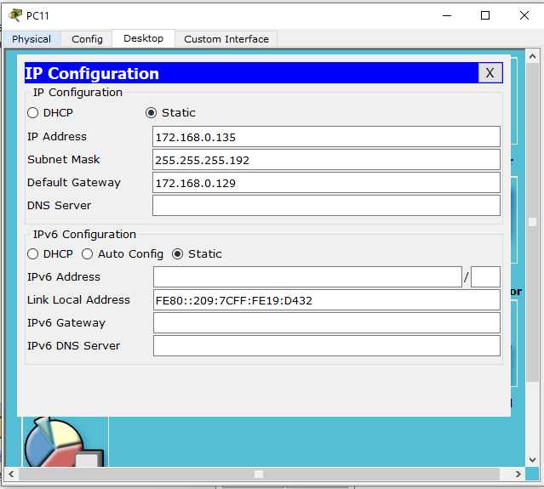

For router-3

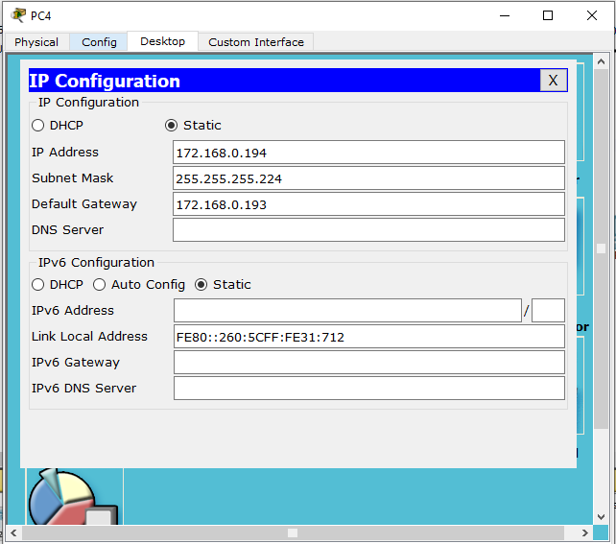

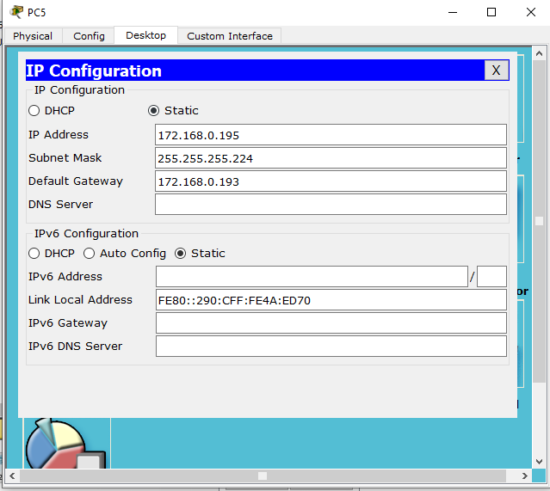

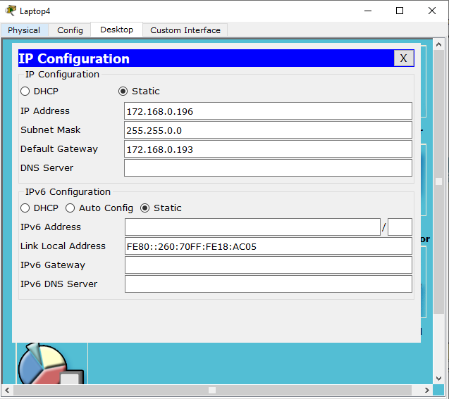

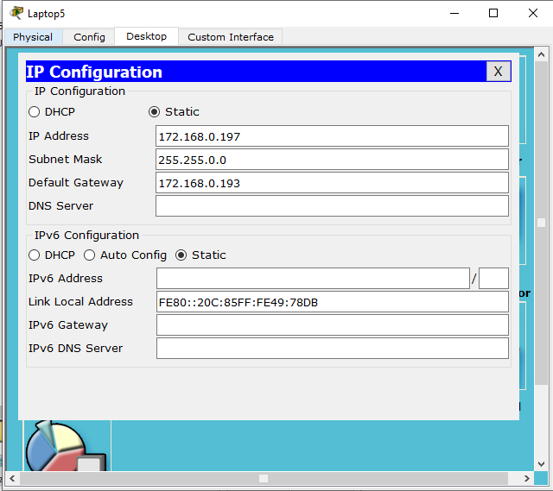

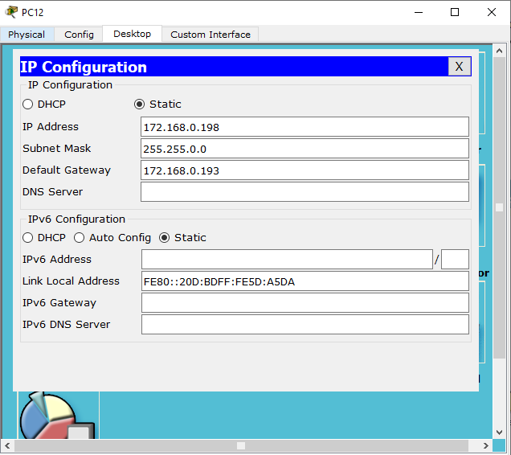

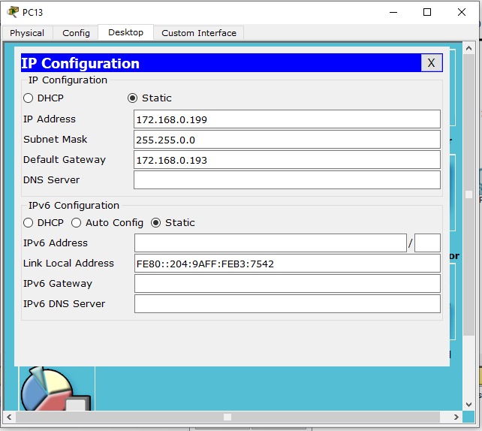

For router-4

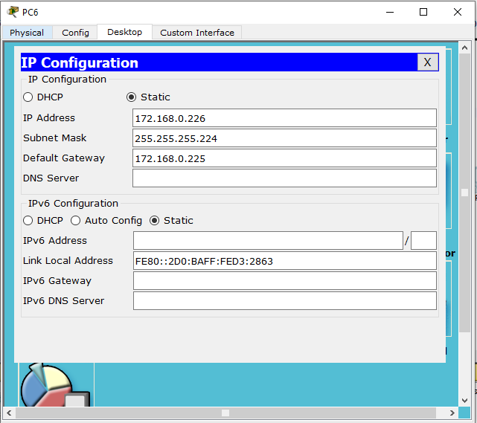

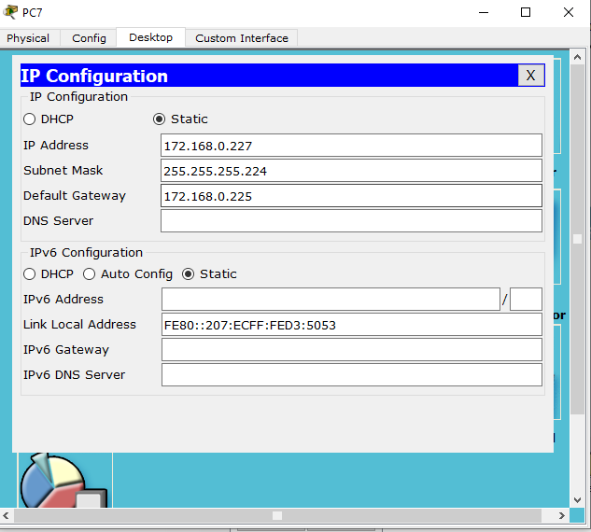

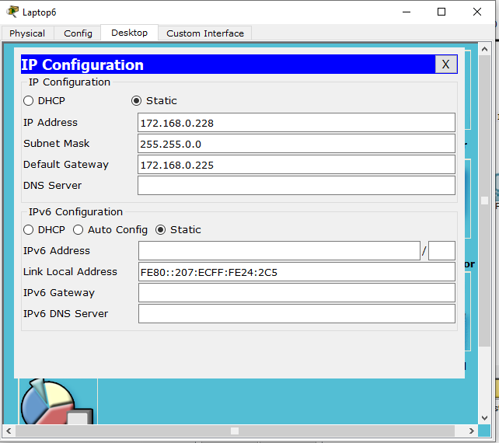

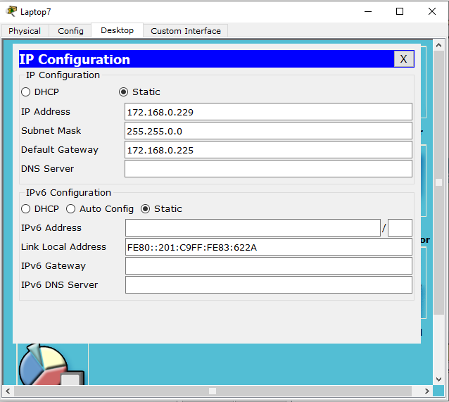

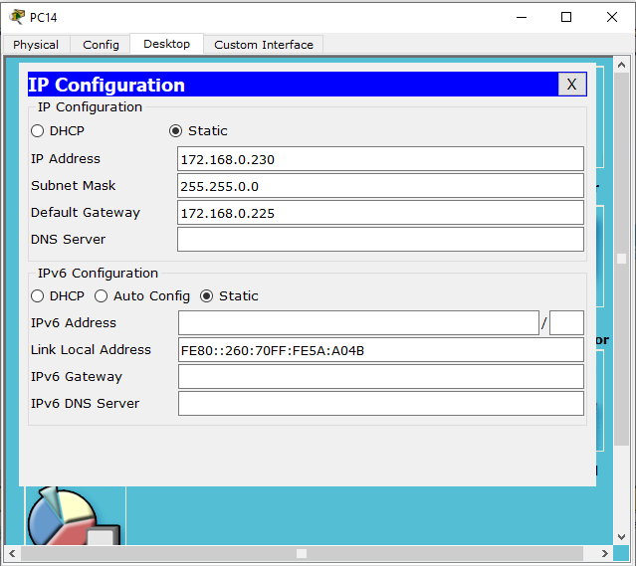

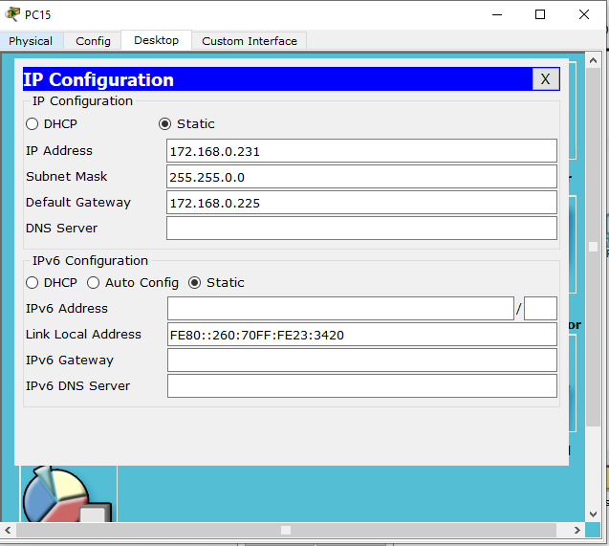

**Step-16:** Verify by pinging each pc/laptops.

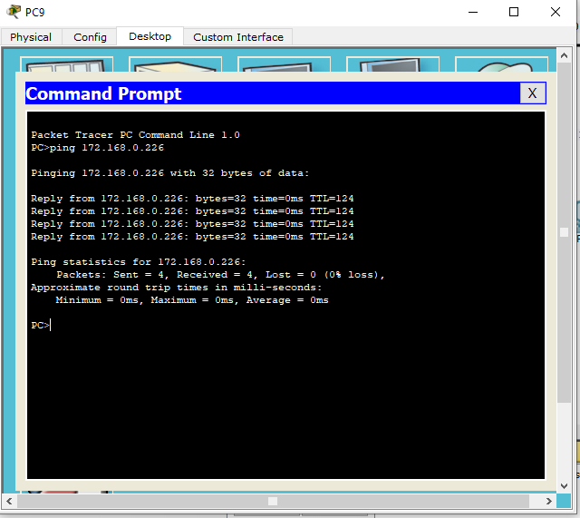

We will see the success rate is 100% after it has founded the route.

**Overall screenshot of the whole architecture-**

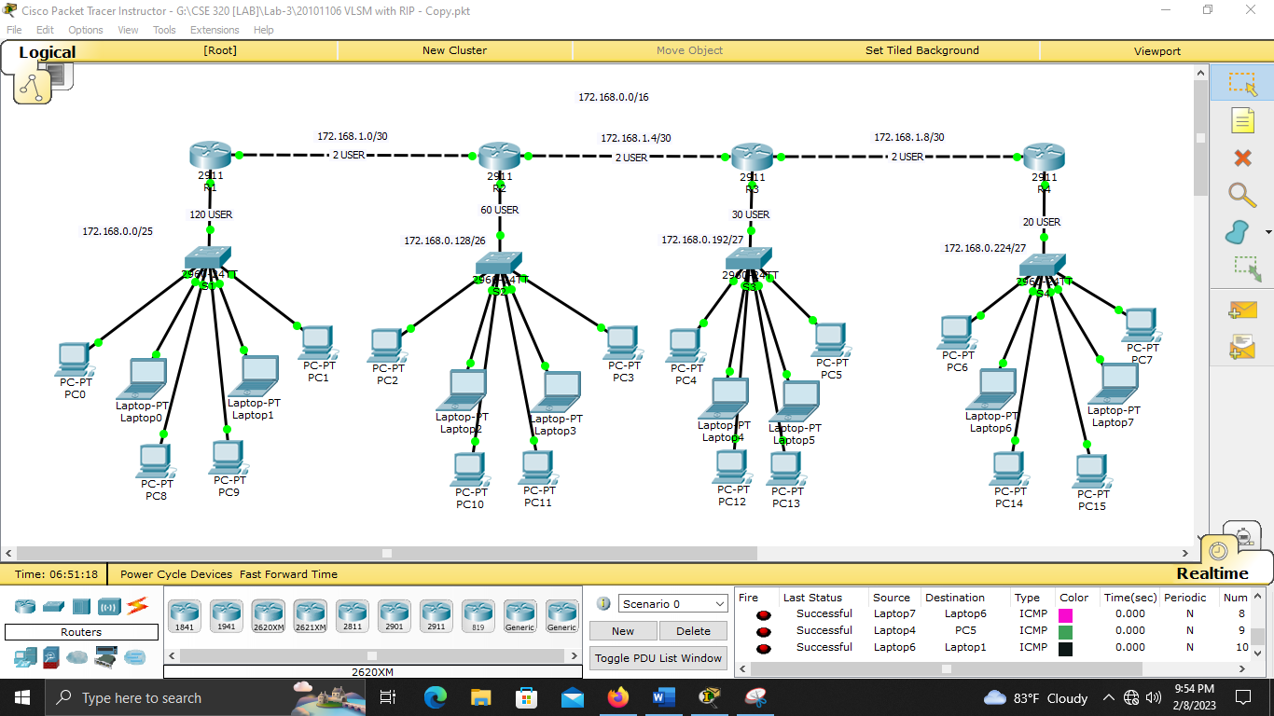

Part by part view-

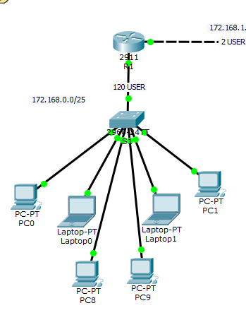

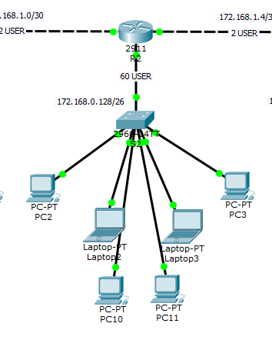

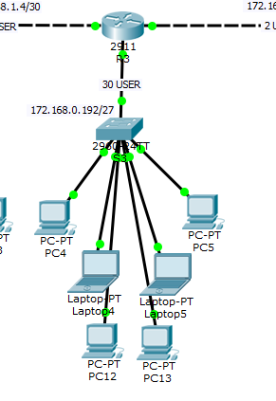

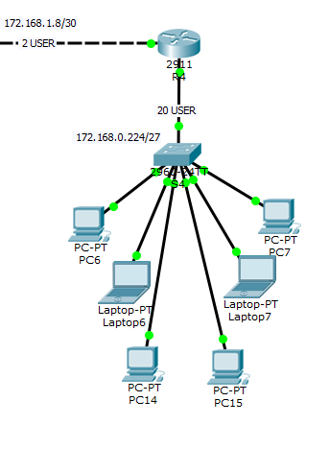

Detailed view-

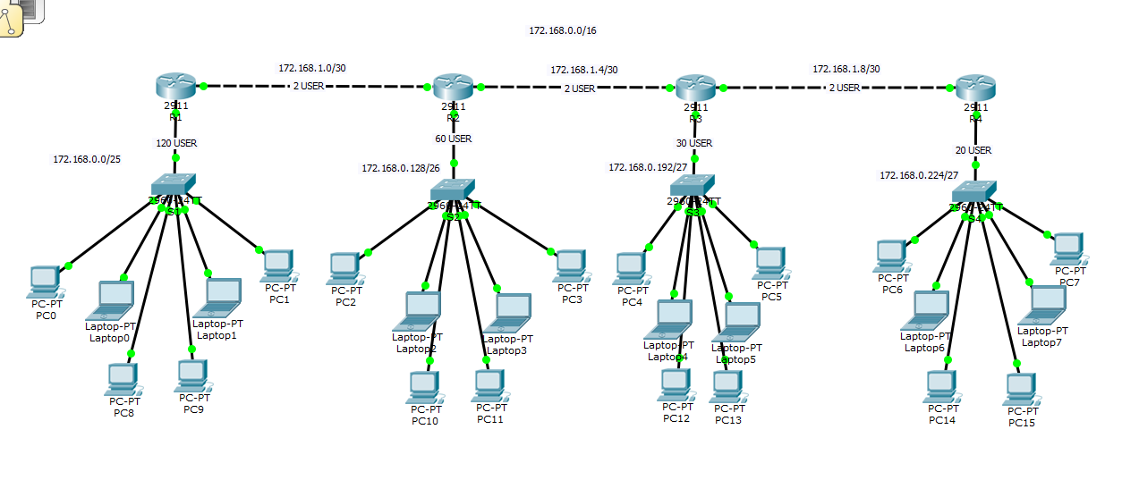

---------------------------THANK YOU FOR READING--------------------------